**Task 3**

**Task 3.1**

Create a file let’s say “khaled.txt” inside the file add more than 10 lines, you can use or download any file: by using commands lines

1. counts the number of lines inside the files.
2. prints the first 5 lines.
3. outputs the last 10 lines.
4. sorts the input lines alphabetically.

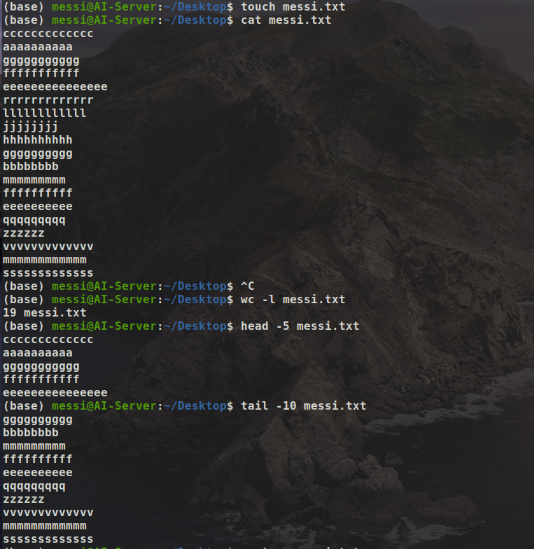

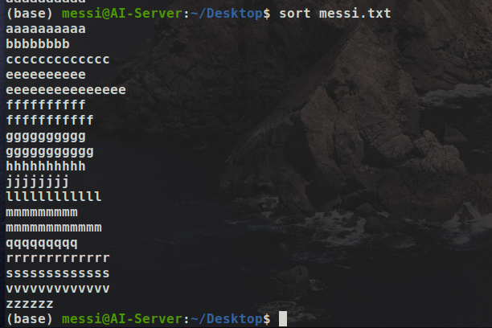

—---------------------------------------------------------------------------------------------------------------------

**Task 3.2**

**Setting your own variable:**

Let’s learn how to set your own **variables** inside the script file…  
1. First variable “Hello” Second variable “Your Name”, You should add 2 variables inside your script and run the script showing “Hello Your Name”.

**Note**: don’t use **echo.**

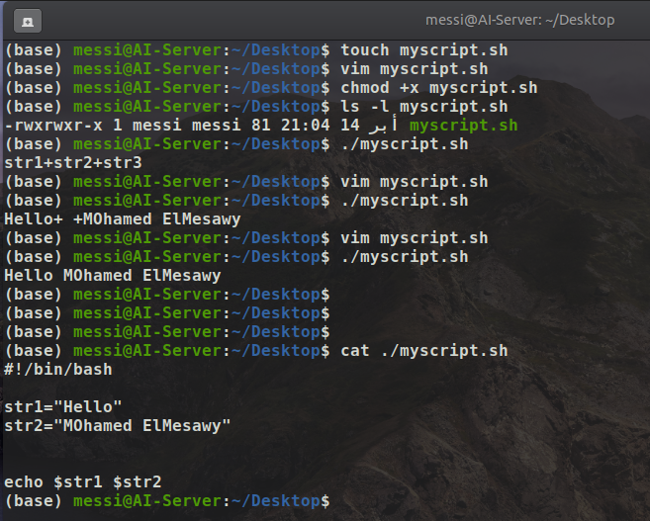

**—------------------------------------------------------------------------------------------------------------------------**

**Task 3.3**

**You have a cpp code and below you can find the equation check the image. I need to put this equation inside the code. it’s allowed to use any programming language.**

#include <iostream>

#include <math.h>

using namespace std;

double f(double mu, double sigma2, double x)

{

//Use mu, sigma2 (sigma squared), and x to code the 1-dimensional Gaussian

**//Put your code here**

//double prob =

return prob;

}

int main()

{

cout << f(10.0, 4.0, 8.0) << endl;

return 0;

}

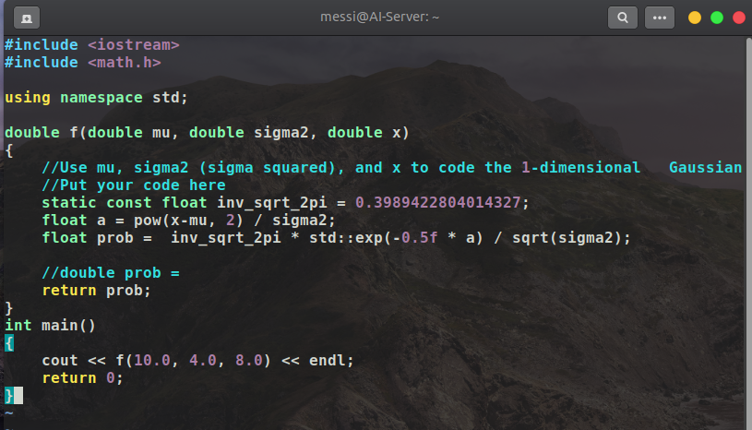

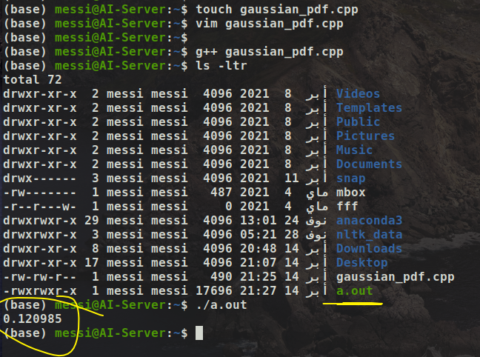

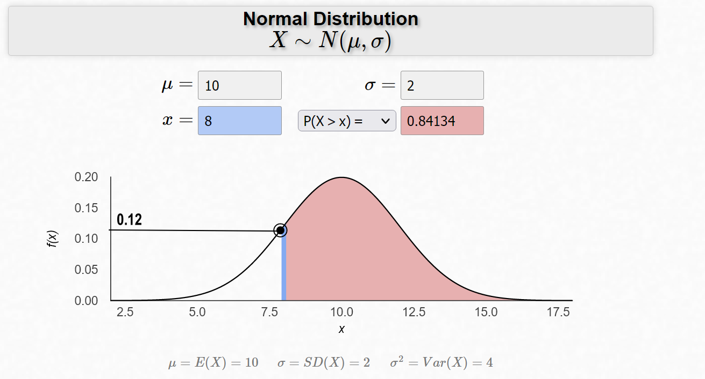

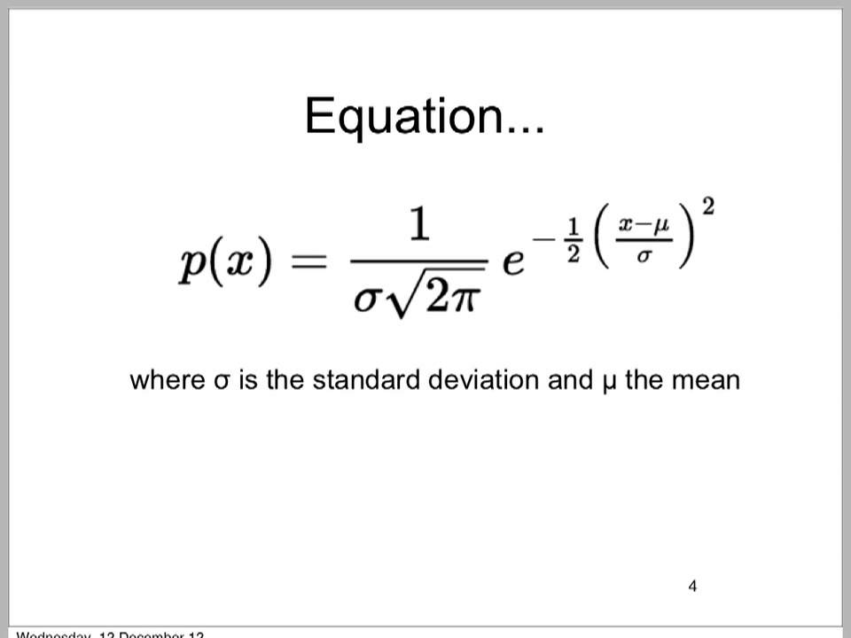

**Task 3.4**

Let’s say in your future company they decide to give you a task, this task is to design a Hardware architecture for their robot.  
First thing you need to ask them is what the robot features and functions. So the robot function is an Autonomous mobile robot made for social environments(helping, serving,..).

The robot used some sensors for doing it’s functions,  
1- Lidar  
2- Depth camera  
3- IMU  
4- Encoder   
5- Thermal camera  
6- Speaker and Mic  
7- RFID reader   
8- TouchScreen

9- **single board unit**  
10- **Arduino**

I bold these 2 units sure for a reason..Keep searching please.

Now you know everything, your task is to create a HW architecture for your robot.

**Guys Keep it very simple!!**

**Note**: I’m not expecting you to do this task 100%, what I’m expecting is to start working on it and start knowing sensor names, and sensor functions, and start searching about HW architecture.

I will accept all answers, I will discuss it deeply with ppl who will work on this task.

Before starting working on the task, please start reading the task carefully.

